Legal Case Email Automation
Zapier | Webhooks | Paths | Gmail | Email Automation

Project Overview
Built an automated legal case email workflow using Zapier to receive case data, evaluate different conditions, and send the appropriate email based on the case stage.
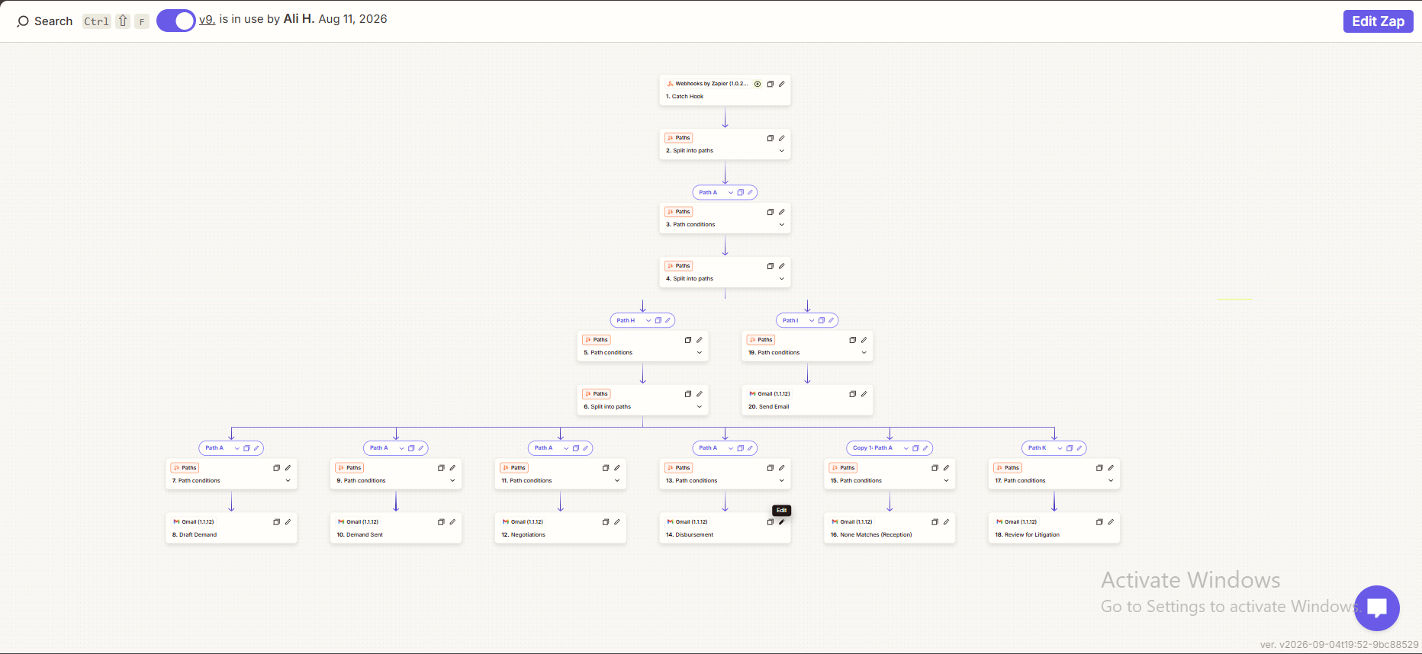

Workflow
The automation:
• Receives data through a webhook
• Checks the incoming case information
• Routes the data through different paths
• Applies conditions for each case stage
• Sends the relevant email through Gmail

Automated Case Stages
The workflow handles different case situations including:
• Draft Demand
• Demand Sent
• Negotiations
• Disbursement
• No Matches
• Review for Litigation

Email Automation
Each path contains its own conditions and email action, ensuring the appropriate message is sent based on the case information.

Technology
• Zapier
• Webhooks
• Paths & Conditions
• Gmail
• Automated Email Workflows

Result
A structured legal case communication workflow that automatically receives case information, determines the appropriate stage, and sends the corresponding email without requiring manual routing.

